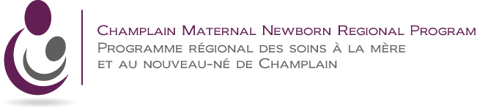

**Preparing to Become a Parent…**

**Before Baby’s Arrival**

* **An Innovative Strategy -**

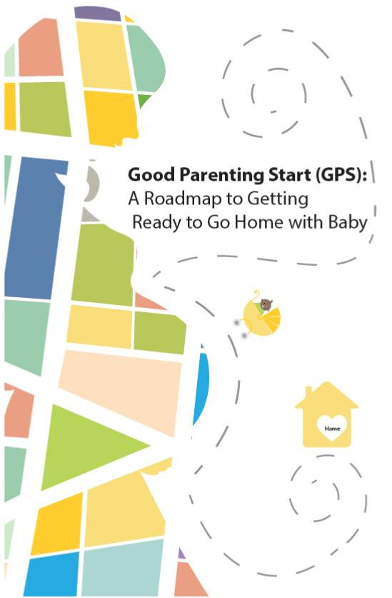

**CMNRP’s Postnatal Plan Workgroup Report:**

**Executive Summary**

Prepared by:

**Christina Cantin & Lauren Rivard, Perinatal Consultants, CMNRP**

on behalf of the

CMNRP Postnatal Plan Workgroup

June 2018

# Executive Summary

In January 2017, a workgroup of new parents and interprofessional perinatal care providers from across eastern and southeastern Ontario was convened to explore ways in which we could assist expectant mothers to better prepare for the immediate postpartum period. After conducting an environmental scan to confirm that no tool existed to achieve this purpose, the workgroup conceptualized and designed a checklist called the *Good Parenting Start (GPS): A Roadmap to Getting Ready to Go Home with Baby*. The GPS focused on topics identified by the workgroup parents as being most important to them, having recently transitioned to home with a new baby. The workgroup then designed a pilot intervention study using a pre/post survey design. The purpose of the study was to evaluate the checklist. Research ethics board approval was obtained for this project. Funding was received from the Women’s College Hospital, Women’s Xchange 15K Challenge.

134 pregnant women enrolled in the study and completed a pre-intervention survey. 95 participants completed a post-intervention survey (response rate = 70.9%). Forty percent (n=38) of the participants who completed the post-intervention survey identified that they used the GPS checklist given to them during their pregnancy. Of those that did not use the GPS, the most commonly identified reason was because they forgot about it (68.4%). No participants indicated that the checklist was too difficult to use.

Of the participants who used the checklist, 94.7% thought the checklist was very easy/somewhat easy to use, 78.9% thought the checklist made them think about topics or situations that they may not have thought about and 94.7% thought that the checklist touched on most topics of concern. There was a high level of satisfaction with the checklist and 65.8% indicated that they would use the checklist for a future pregnancy. Many participants would have preferred receiving the checklist electronically and earlier in pregnancy.

Surprisingly, it appeared that those who did not use the checklist reported a higher rating of feeling “definitely ready” to go home after birth, compared to those who used the GPS checklist (60.7% vs 50%). Approximately 2/3 of participants were aware of some community resources, regardless of use of the checklist, and 10.5% overall indicated that they were “not aware of any community resources”. This indicates that more work needs to be done to raise awareness of existing resources.

Given the positive results of this pilot, the following recommendations were made by the workgroup:

1. Explore the potential of revising the GPS checklist in light of feedback received and opportunities for alternative formatting and distribution options.
2. Encourage organizations and health care providers choosing to implement the checklist to provide it to pregnant women early in the prenatal period and as part of an integrated education strategy.
3. Suggest and highlight high quality resources that perinatal care providers can use to complement the checklist.
4. Collaborate with partners to create public health messaging “from moms to moms” about the importance of preparing for parenting during the prenatal period.

# 